***Summary***

**Dataset**

our dataset is 30 samples

split into 85% - 15% segments for training and validation sets respectively.

**Model**

the deep learning model is built with the python Keras framework

as this is a regression problem here’s our model architecture.

*Model architecture & Hyper parameters*

* **Input layer** : 4 input nodes
* **Hidden layer 1** : 32 nodes
* **Activation function**: ReLU
* **Hidden layer 2** : 8 nodes
* **Activation function**: ReLU
* **Hidden layer 3** : 8 nodes
* **Activation function**: ReLU
* **Output layer** : 1 node
* **Activation function**: Sigmoid
* **Loss** : MSE (mean squared error)
* **Optimizer** : Adam

*Model Loss Graph*

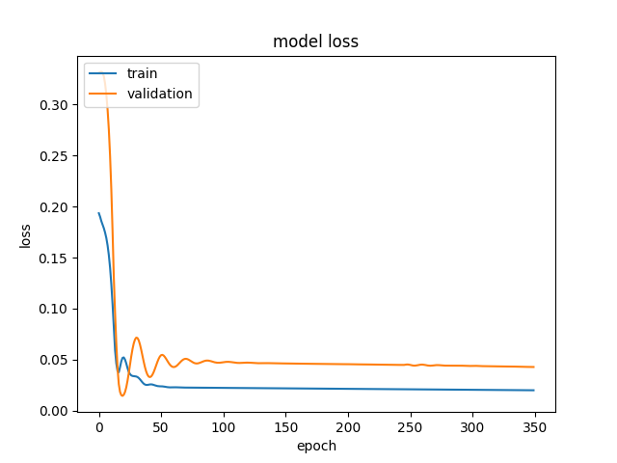

**Graphical User Interface**

QT framework is used to build the GUI .ui file

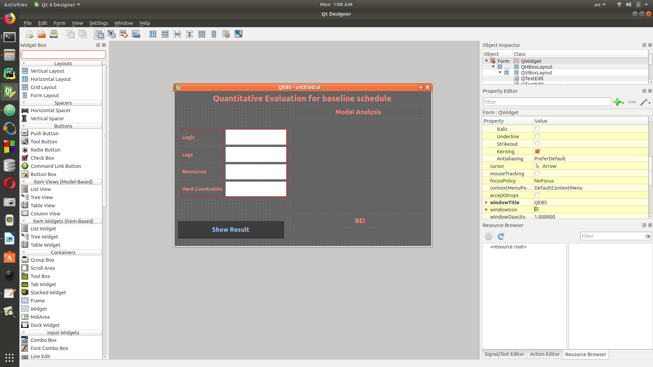

then the .ui file is converted to a .py file

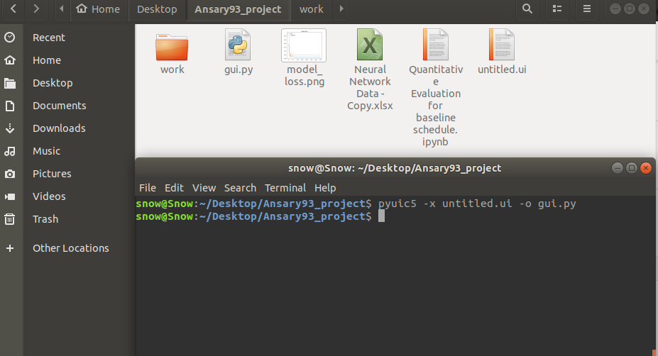

then we started working on the .py file with the PyQt5 library

